19.3:

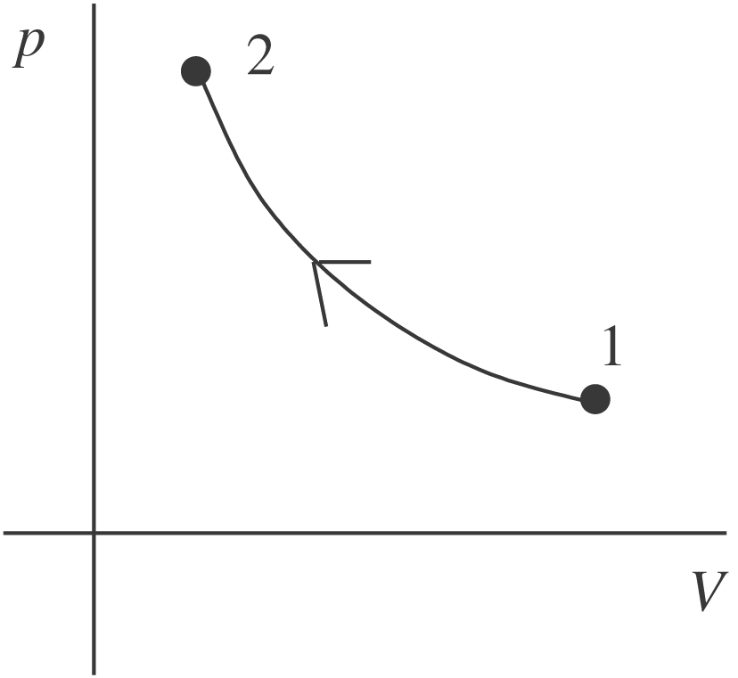

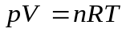
T constant, so when p increases, V decrease

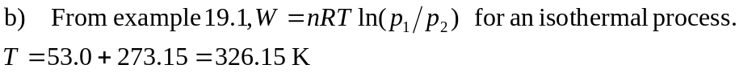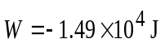 The work done by the gas is negative because the volume decreases.

